CHINESE FLAGSHIP SECONDARY CURRICULUM
LEVEL 2, UNIT 3: Food and Restaurant
Assessment: Interpretive Reading

_{Learning Targets}
I can recognize food and drink items on a Chinese menu.
I can order food items.
- I can read a menu and and comprehend food and drink items written in Chinese.
- I can recognize different food categories

Proficiency Goal
Novice Mid
Novice Low
Intermediate Low
Intermediate High
Novice High
Intermediate Mid

Scenario
You are having dinner in a Chinese restaurant with a friend who does not know any Chinese. Below is a authentic Chinese restaurant menu. Please order three dishes for you and your friend. Try to make sure you have two dishes with chicken, one dish with beef, and another that is vegetables.

Please answer the following questions:

1. 请问，你想点什么？

2. 哪道菜里有鸡肉？

3. 哪道菜里有牛肉？

4. 哪道菜里有蔬菜？

5. 一共多少钱？

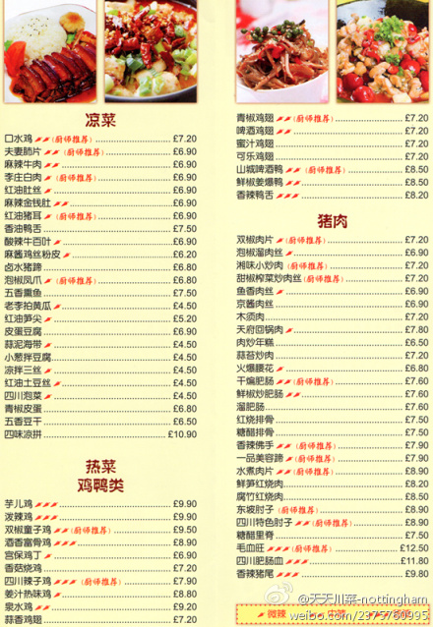

Adapted from Jefferson County Public Schools, KY, 2011

